**Activity on: Momentum and Collisions, and Newton’s Third Law**

You will be given two identical carts and a (almost) frictionless track for this hands-on activity. There are three investigations to be conducted.

**Investigation 1:**

You will have one cart positioned in the middle of the track and you will accelerate the other one from one end of the track toward the one in the middle with a certain speed. This is depicted below. But before you conduct the experiment, you are expected to make a quantitative prediction as to what the speeds after the collision will be. This will be done symbolically. `

**Prediction:**

**1-) What principle(s) or law(s) of physics are you supposed to use here? Indicate that below and provide your justification for it (them).**

**2-) Carry out your calculation to determine the speeds after the collision below.**

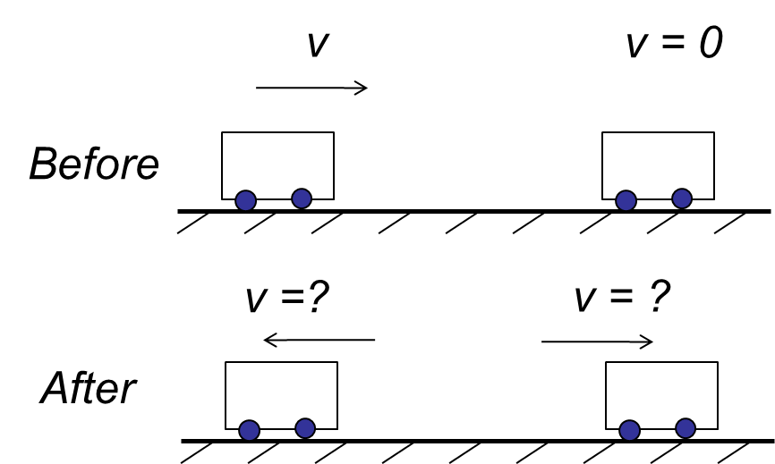

**Experiment:**

1-) Now, do perform this experiment to check on your prediction. What result do you get?

2-) Does your prediction agree with the experiment? If not, revisit your prediction calculation and revise your prediction (show your work below) to be in accord with the experiment.

3-) If need be, redo the experiment.

**Investigation 2:**

Now, try to accelerate the two carts against each other with as equal speed as you can manage to get. This is depicted below. But before you conduct the experiment, you are expected to make a quantitative prediction as to what the speeds after the collision will be. This will be done symbolically. `

**Prediction:**

**1-) What principle(s) or law(s) of physics are you supposed to use here? Indicate that below and provide your justification for it (them).**

**2-) Carry out your calculation to determine the speeds after the collision below.**

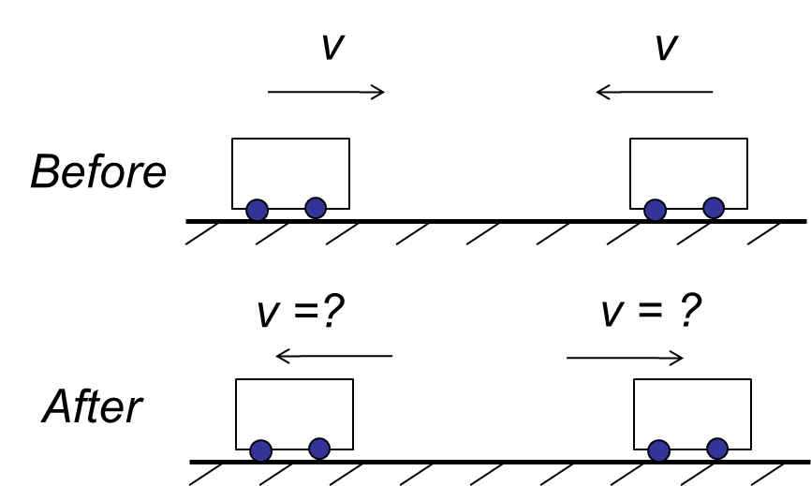

**Experiment:**

1-) Now, do perform this experiment to check on your prediction. What result do you get?

2-) Does your prediction agree with the experiment? If not, revisit your prediction calculation and revise your prediction (show your work below) to be in accord with the experiment.

3-) If need be, redo the experiment.

**Investigation 3: Newton’s Action-Reaction Law and Collisions**

Dr. Zorba will illustrate, using force sensors and carts, how the Action-Reaction law is always valid in collisions, regardless of the difference and discrepancy between masses and/or speeds of the colliding objects.